Arithmetic Calculator
Documentation

Introduction
This short document to give a short description about the task (building arithmetic calculator). The application is build based on the requirements stated by “HPE”:
“Assignment Topic: Design and implement an service evaluating algebraic expressions in JAVA.
Deliverables: source codes, build script creating an war file deployable on an common servlet container (e.g. Tomcat)
Assignment: Design an input format suitable for representation of algebraic expressions. (e.g. XML, JSON, plaintext prefix notation.. whatever).
The expression can contain:
- integer constant
- string constant
- binary operators +,-,*,/
- unary operator sizeof (string) – length of the string argument
- unary operator abs(int) - absolute value of the integer argument
Actual syntax does not matter ( element name "plus" suits well XML format while symbol "+" can be convenient for plaintext notations).
Then implement an service evaluating the input expression in Java using the technologies of your choice (REST, SOAP, plain network sockets, Spring, JAX-WS).
When invoked with a valid request the service will produce a response using the same format (result is either string or integer constant)
When evaluating the solution we well be interested in particular:
- object oriented design
- design patterns
- modular and extensible design
- maintainability of the delivered artefacts
- correct usage of the selected technologies
- justification of the selected technologiesThe next few sections will provide more description about the Java project.”

Technologies used:
The following frameworks, libraries, and build tools have been used to build the project:
Spring MVC (4.0.2.RELEASE): MVC framework to build the front layer right before the final views.
JSP & JSTL (1.2): Used to render the model objects returned from Spring MVC.
JAXB: Used to unmarshal the XML format into Java objects model.
Maven: Used to build and resolve the project dependencies.
Oravle WebLogic Application Server (10.3.5): Used to publish the final project artifact (war file).
Eclipse (Kepler Service Release 1): used as an IDE that provides flexibility to use different plugins.

Layers Design:
The following class diagram describes the classes used to build the application:
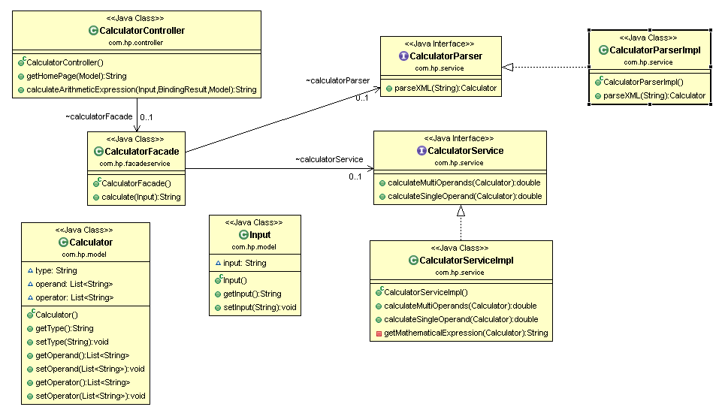

Source code
Eclipse project could be checked out from the public “github” repository:
https://github.com/Mohammed-Rady/Arithmetic-Calculator.git

Screenshots
The below is some screenshots from the application:
The home page of the application will look like:
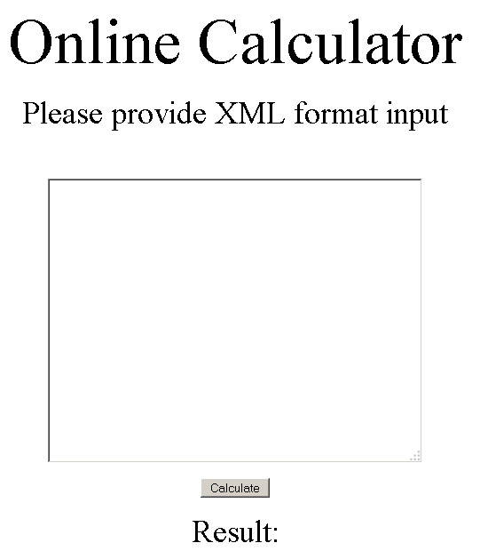
As shown in the screen shot instructions, the prompt is to provide XML format input. The user will be able to provide two types of inputs:
- Multi-operands input (+, -, *, /).
- Single-operand input (abs(number), sizeOf(string)).
The following screen shot shows the first type of the input (Multi-operands input):
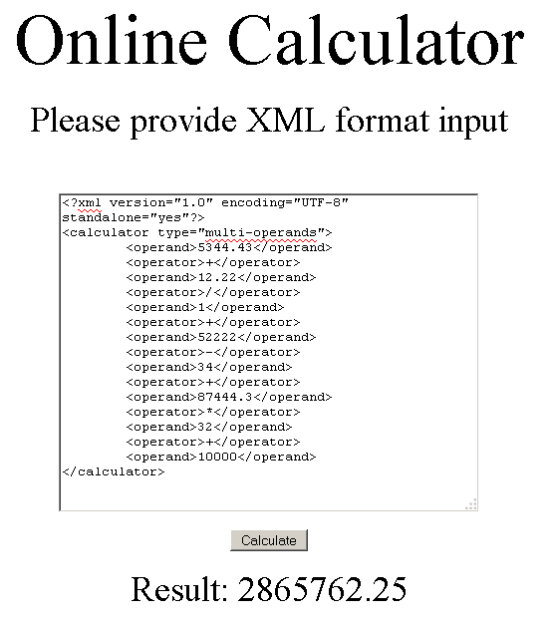
The next two screens show the second type of the input (single-operand input):
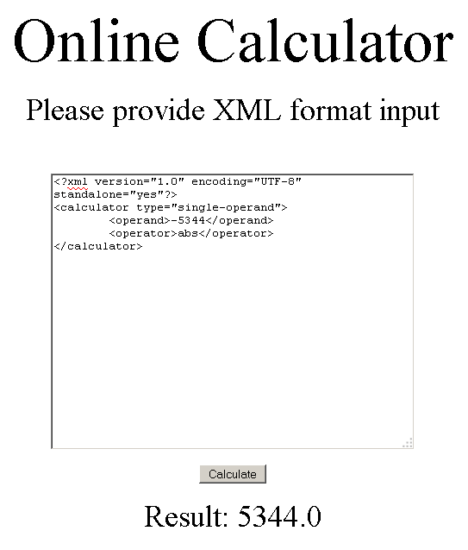
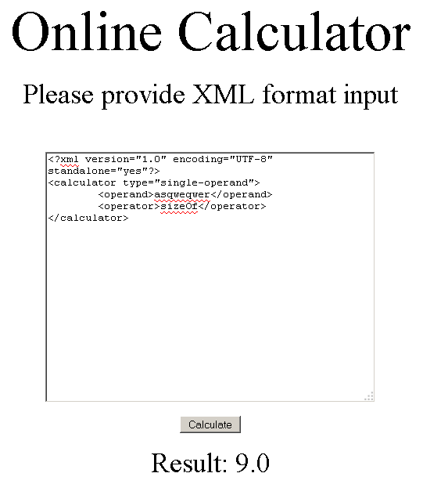

IDE Screenshot:

